Marco Rodriguez Gomez
04/23/2026
Assignment: Test Cases

city_functions.py
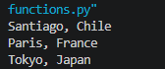

test_cities.py
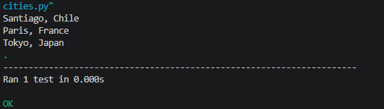

test_cities.py
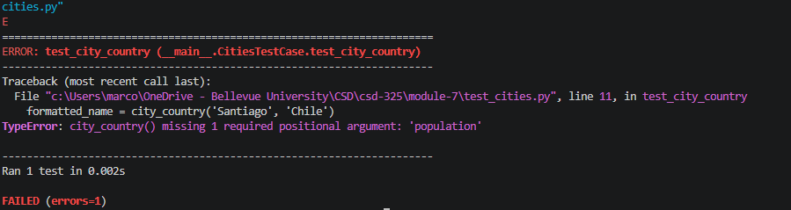

test_cities.py
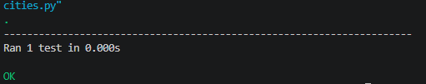

test_cities.py
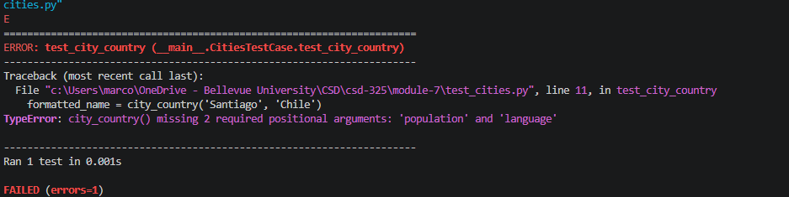
test_cities.py
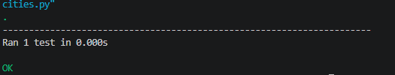

city_functions.py
